JAVA NOTES

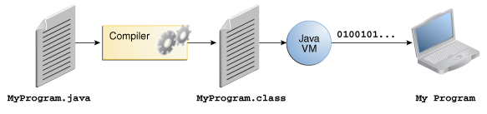

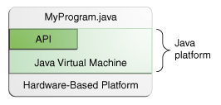

The API is a large collection of ready-made software components that provide many useful capabilities. It is grouped into libraries of related classes and interfaces; these libraries are known as packages.

public static void main(String[] args)

The main method is similar to the main function in C and C++; it's the entry point for your application and will subsequently invoke all the other methods required by your program.
Compile time error: Syntax errors, semantic errors

What Is an Object?
An object is a software bundle of related state and behavior. Software objects are often used to model the real-world objects that you find in everyday life. This lesson explains how state and behavior are represented within an object, introduces the concept of data encapsulation, and explains the benefits of designing your software in this manner.

Real-world objects share two characteristics: They all have state and behavior. Dogs have state (name, color, breed, hungry) and behavior (barking, fetching, wagging tail). Bicycles also have state (current gear, current pedal cadence, current speed) and behavior (changing gear, changing pedal cadence, applying brakes).

What Is a Class?
A class is a blueprint or prototype from which objects are created. This section defines a class that models the state and behavior of a real-world object. It intentionally focuses on the basics, showing how even a simple class can cleanly model state and behavior.

You may have noticed that the Bicycle class does not contain a main method. That's because it's not a complete application; it's just the blueprint for bicycles that might be used in an application. The responsibility of creating and using new Bicycle objects belongs to some other class in your application.

What Is Inheritance?
Inheritance provides a powerful and natural mechanism for organizing and structuring your software. This section explains how classes inherit state and behavior from their superclasses, and explains how to derive one class from another using the simple syntax provided by the Java programming language.

Object-oriented programming allows classes to inherit commonly used state and behavior from other classes. In this example, Bicycle now becomes the superclass of MountainBike, RoadBike, and TandemBike. In the Java programming language, each class is allowed to have one direct superclass, and each superclass has the potential for an unlimited number of subclasses:

What Is an Interface?
An interface is a contract between a class and the outside world. When a class implements an interface, it promises to provide the behavior published by that interface. This section defines a simple interface and explains the necessary changes for any class that implements it.

Implementing an interface allows a class to become more formal about the behavior it promises to provide. Interfaces form a contract between the class and the outside world, and this contract is enforced at build time by the compiler. If your class claims to implement an interface, all methods defined by that interface must appear in its source code before the class will successfully compile.

What Is a Package?
A package is a namespace for organizing classes and interfaces in a logical manner. Placing your code into packages makes large software projects easier to manage. This section explains why this is useful, and introduces you to the Application Programming Interface (API) provided by the Java platform.

Real-world objects contain state and behavior.
A software object's state is stored in fields.
A software object's behavior is exposed through methods.
Hiding internal data from the outside world, and accessing it only through publicly exposed methods is known as data encapsulation.
A blueprint for a software object is called a class.
Common behavior can be defined in a superclass and inherited into a subclass using the extends keyword.
A collection of methods with no implementation is called an interface.
A namespace that organizes classes and interfaces by functionality is called a package.
The term API stands for Application Programming Interface.

